|  |  |
| --- | --- |
| **Project – External Documentation** |  |
| COMP6114001 Pattern Software Design |
| Even Semester Year 2022/2023 |

* Project Title

KpopZtation

* Introduction

KpopZtation is a prominent K-pop album shop based in Indonesia. To cater to the growing demand for K-pop albums, KpopZtation has decided to develop a comprehensive website that will serve as an online platform for customers to explore and purchase their favorite K-pop albums. The website will offer a user-friendly interface and a wide range of features to enhance the customers' shopping experience.

* Report / Documentation
  + Register

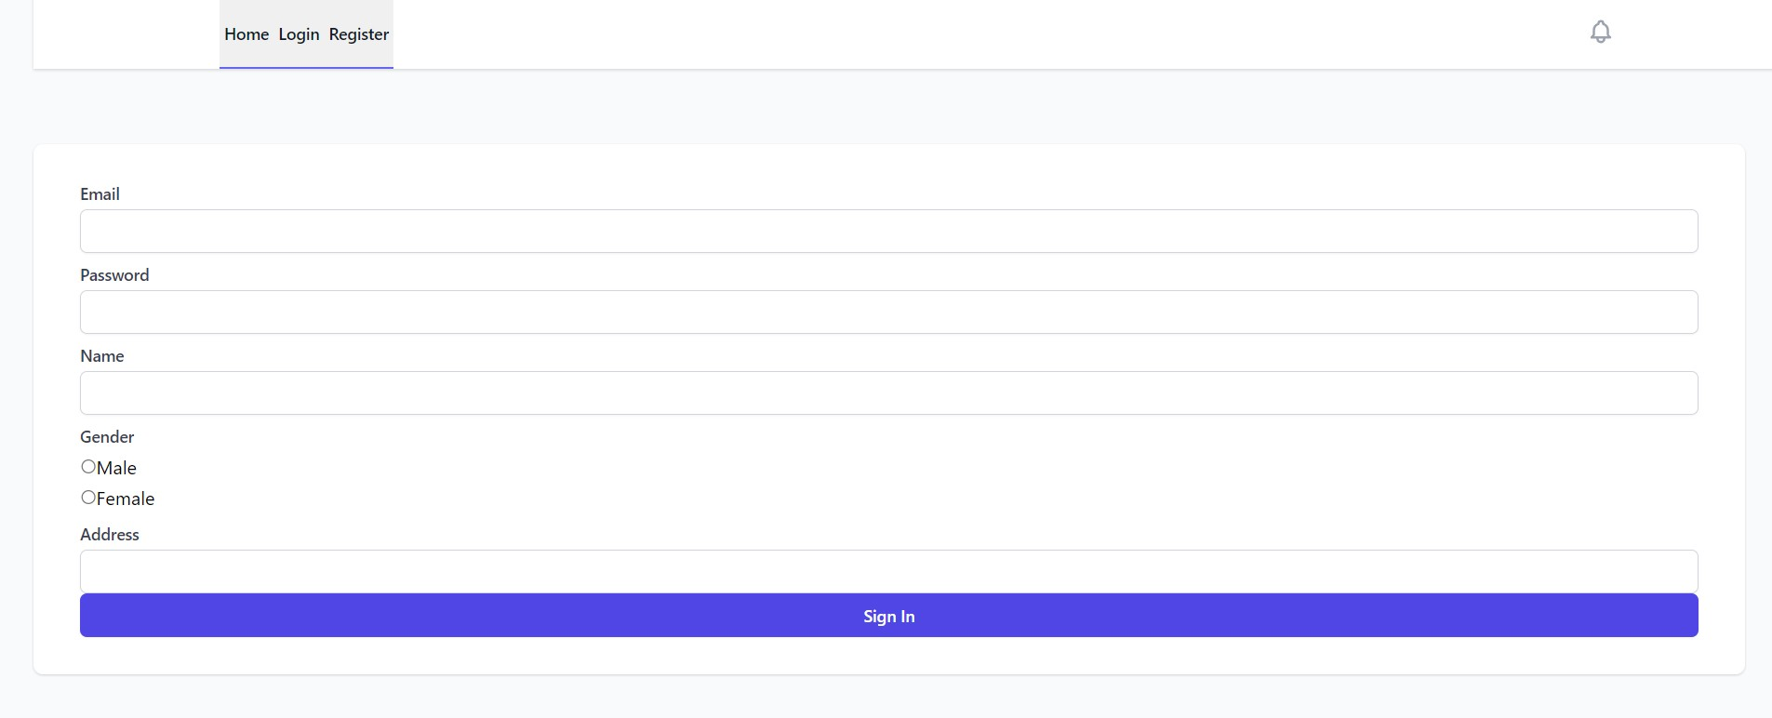

*Figure 1. Register*

On this page the user can register an account into the application by entering the required identity. Entered identity such as name, email, gender, address, and password

* + Login

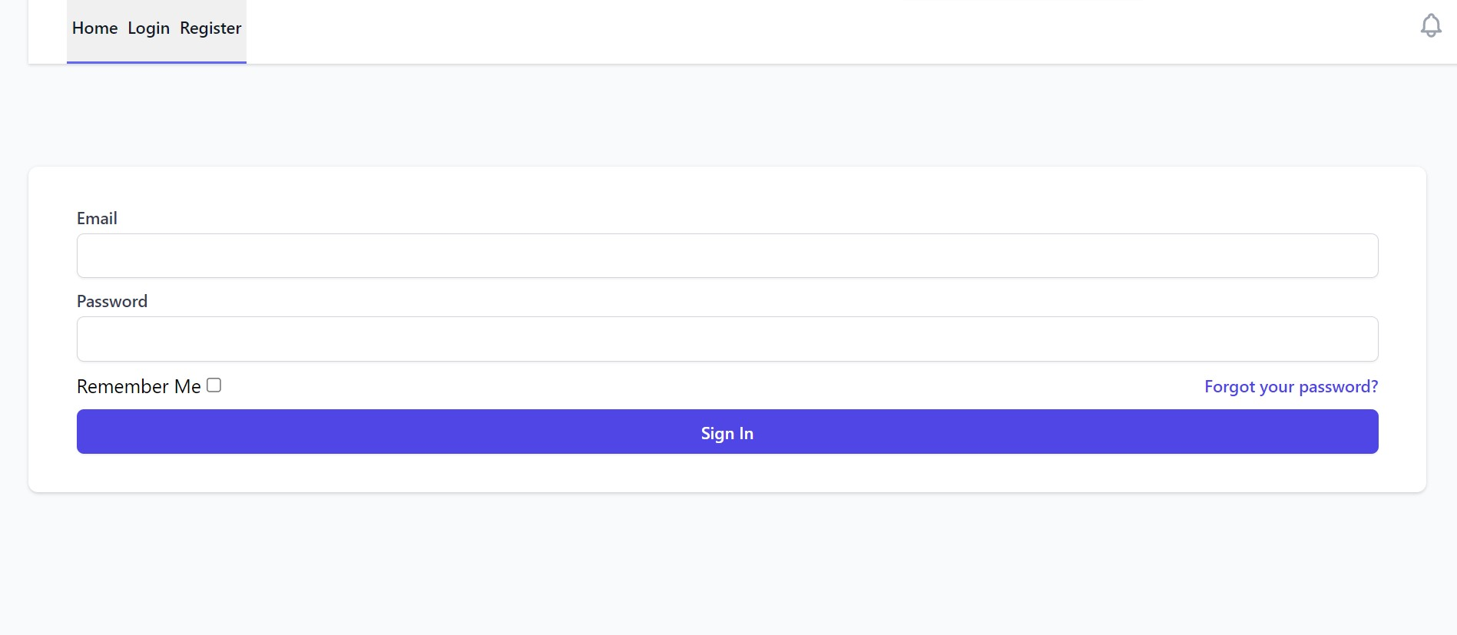

*Figure 2. Login*

On this page the guest can log into the application in order to access features such as buying albums, viewing carts, viewing transaction history.

* + Home

*Figure 3. Home*

On this page the guest, customer, and admin can see what artists have been registered in the application. users can see the artist's profile along with the artist's name.

* + Insert Artist

*Figure 4. Insert Artist*

On this page the admin can enter artist data that will be registered in the application. when entering artist data, the artist data required is the artist's name and photo.

* + Update Artist

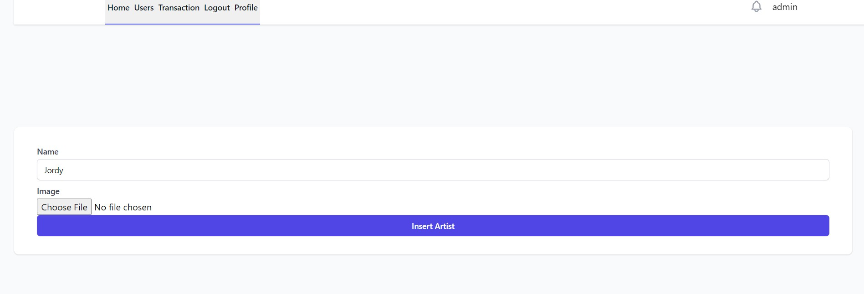

*Figure 5. Update Artist*

On this page admin can update artist data. Artist data that can be updated by the admin is the artist's name and artist photo.

* + View Album

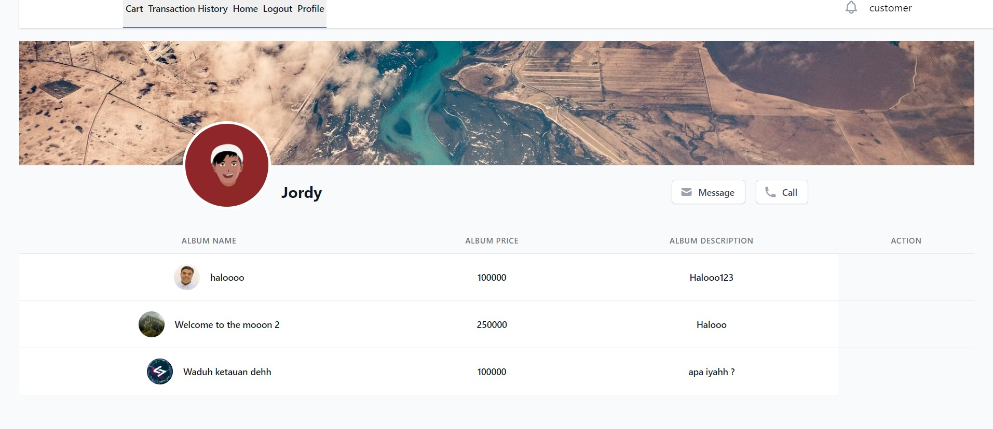

*Figure 6. View Album*

On this page guests, users, and admins can see the albums that the artist has. This page displays several album attributes that can be seen by users such as album name, album price, album description, and album photos.

* + Insert Album

*Figure 7. Insert Album*

On this page the admin can enter a new album owned by the artist. Album attributes that must be entered by the admin are album name, album price, album stock, album description, and album photos.

* + Update Album

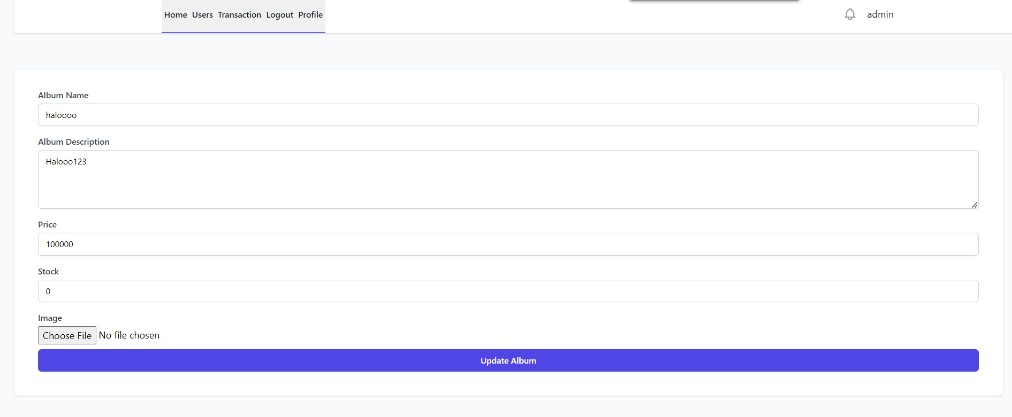

*Figure 8. Update Album*

Album attributes that can be updated by the admin are album name, album price, album stock, album description, and album photos.

* + Update Profile

On this page customers can update their profile. Profile attributes that can be updated by customers are customer name, email, gender, address, and also pass.

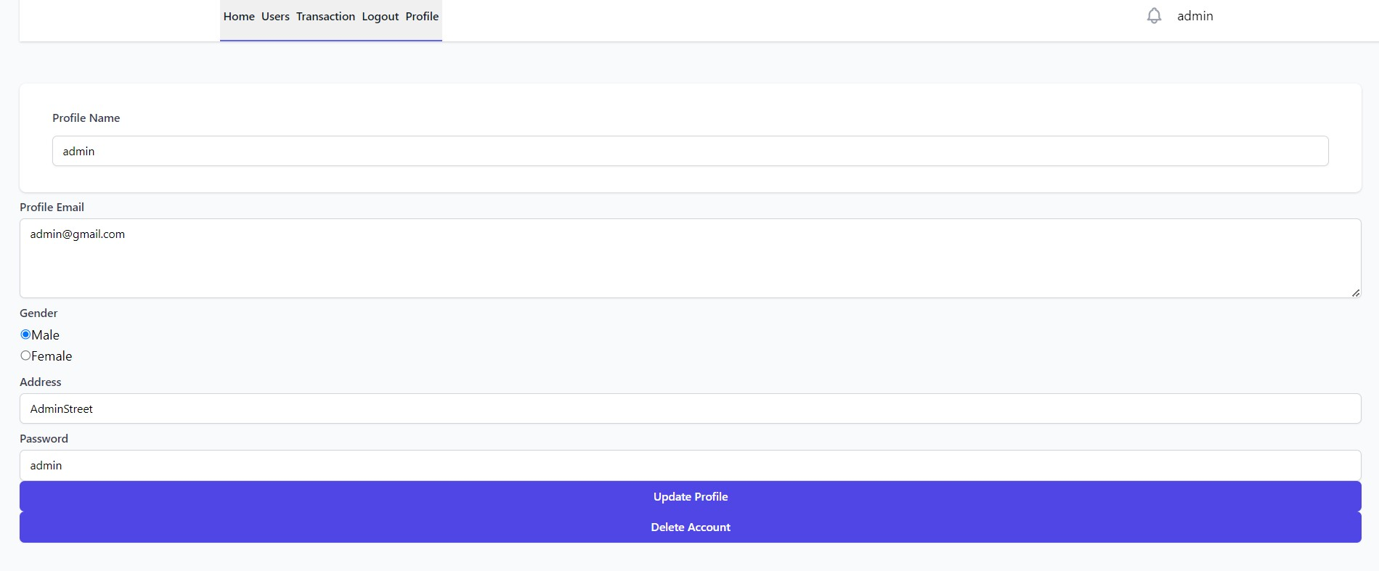

*Figure 9. Update Profile*

* + Delete Account ( Admin )

*Figure 10. Delete Account*

On this page the admin can see all accounts that have been registered in the application, then the admin can delete accounts that have been registered in the application.

* + View Transaction Report

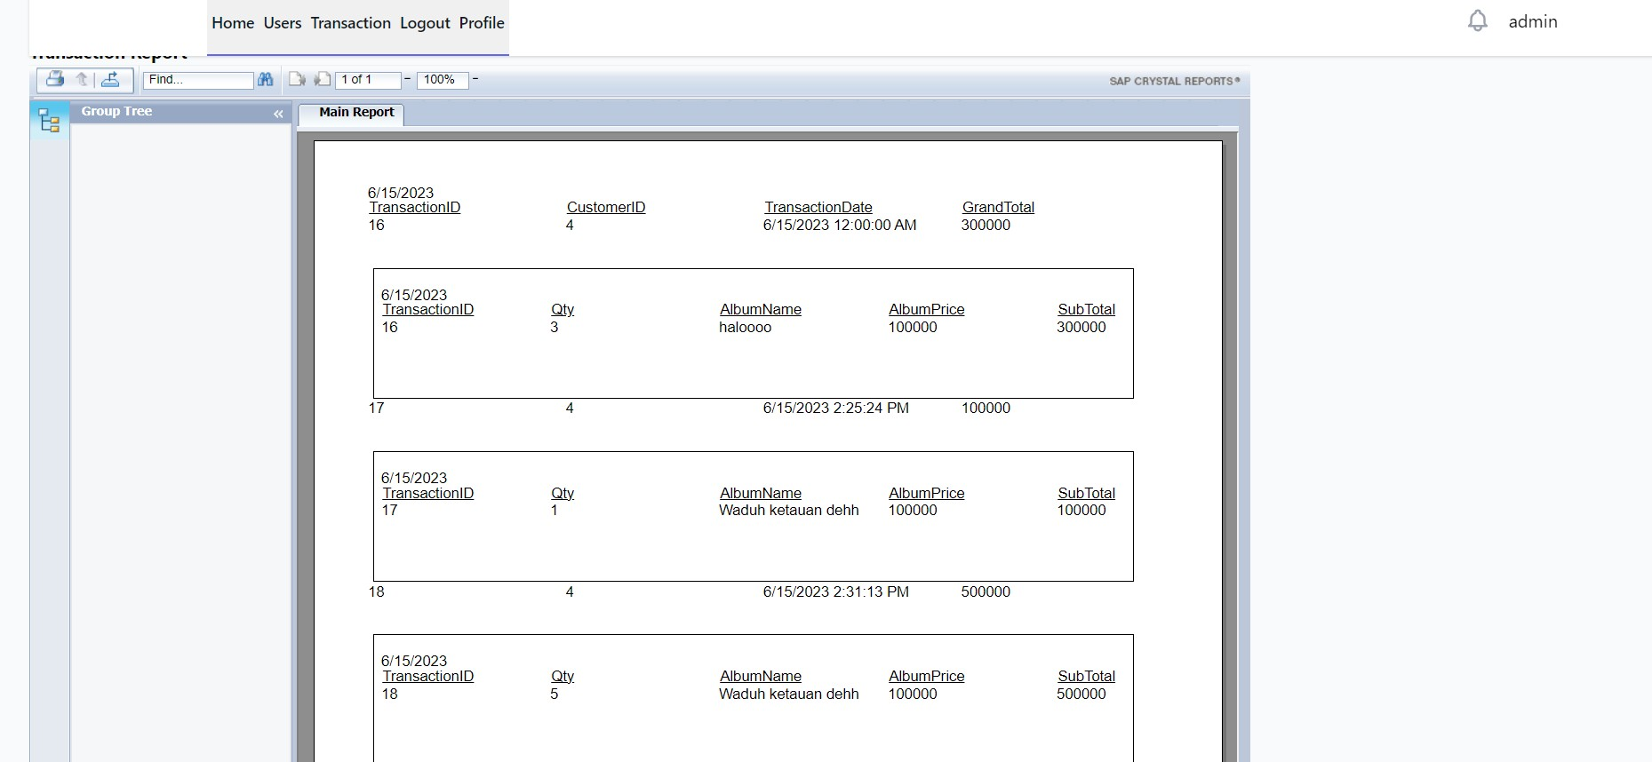 *Figure 11. Transaction Report*

On this page the admin can see the transaction report. there are several attributes displayed in this transaction report such as customer name transaction date, transaction id, customer name, album name, quantity of albums purchased by the user, and album price.

* + Order Album

*Figure 12. Order Album*

On this page customers can see album details such as album name, album price, album stock, and album description. Then on this page the user can buy an album from the artist.

* + View Profile

 *Figure 13. View Profile*

On this page the customer can see his own profile. There are several attributes displayed such as name, gender, address, password and email.

* + View Cart

*Figure 14. View Cart*

On this page the customer can see the albums that are already in the cart, then the customer can delete the albums in the cart if they want, or checkout for albums that are already in the cart.

* + View Transaction History

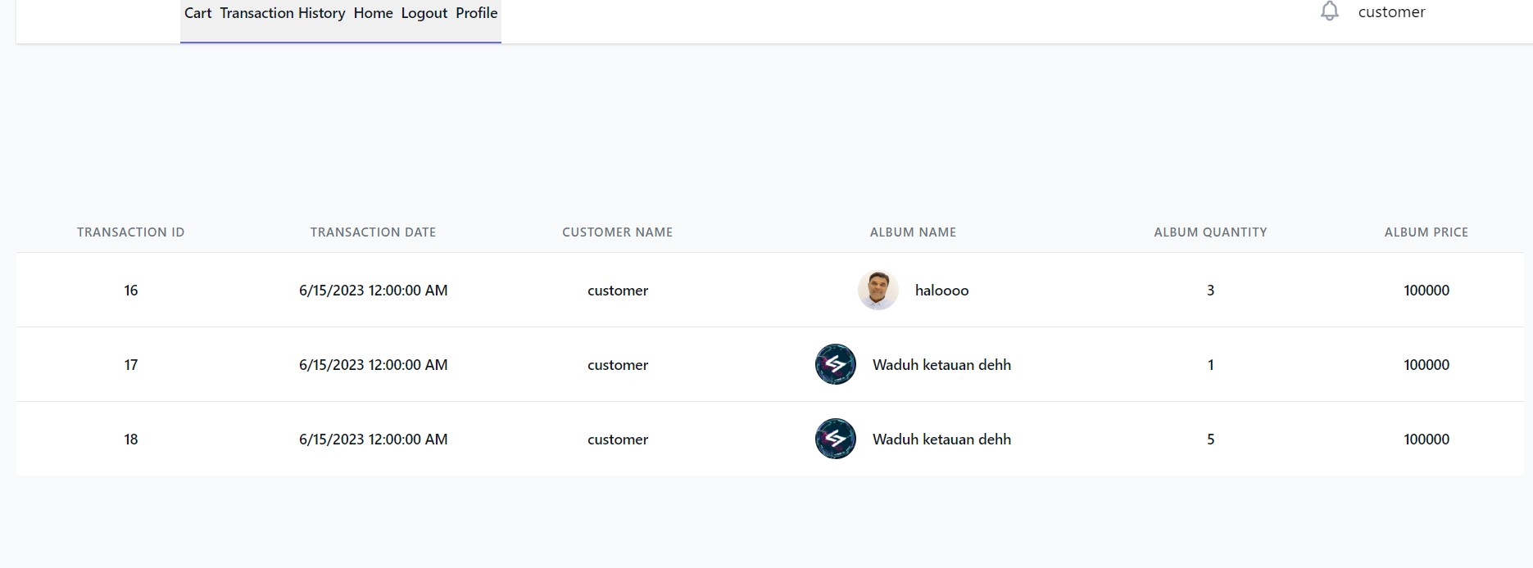 *Figure 15. View Transaction History*

On this page the customer can see the transaction history. There are several attributes displayed such as customer name transaction date, transaction id, customer name, album name, quantity of albums purchased by the user, and album price.

* Reference
* https://tailwindcss.com/
* <https://yt3.googleusercontent.com/ytc/AGIKgqP3TgkRT1QjI9c9ZowIY7zJARkufxIGnajF0-C_=s900-c-k-c0x00ffffff-no-rj>
* https://steamuserimages-a.akamaihd.net/ugc/2014835831042246030/890B6716B0B77EBAD1F007BBE45CB9F5F668B45B/?imw=512&&ima=fit&impolicy=Letterbox&imcolor=%23000000&letterbox=false
* Group Member
* 2501972221 – Justine Winata Purwoko
* 2540122426 – Vito Caris Untariady
* 2501997722 – Hady Gustianto
* 2502059215 – Muhamad Fitrayuda